### BIS097

### BGP160E

Assume all 100m

54 transects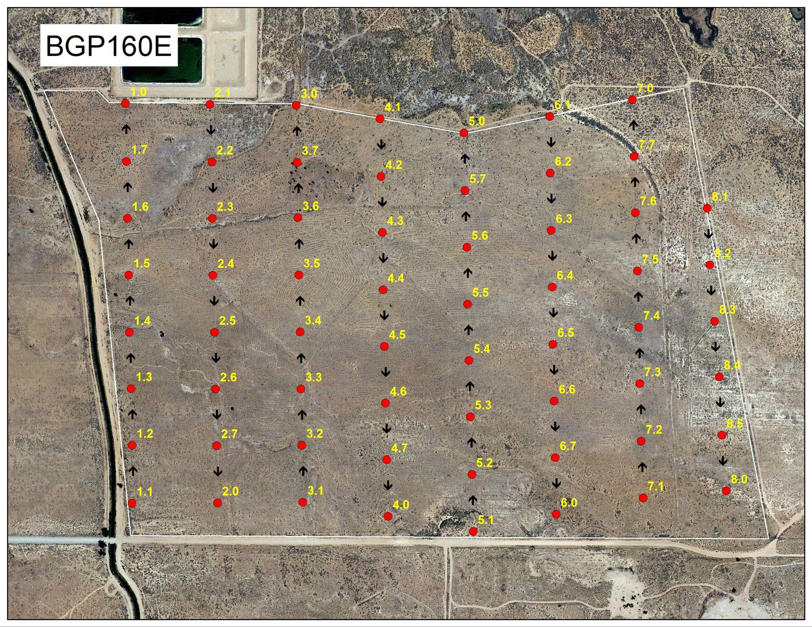

### 

### BGP160W

All 100m

Except

1.1->1.2 90m

2.1->2.2 74m

3.2->3.2 60m

4.1->4.2 46m

### 

### 

### 

### TIN054

None yet

### BLK16E

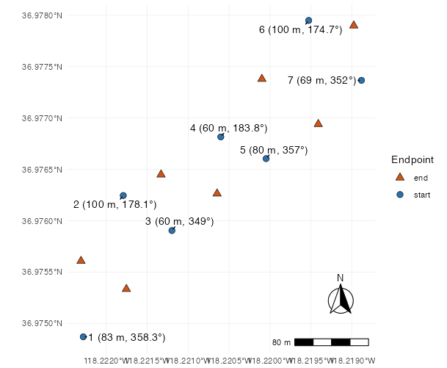

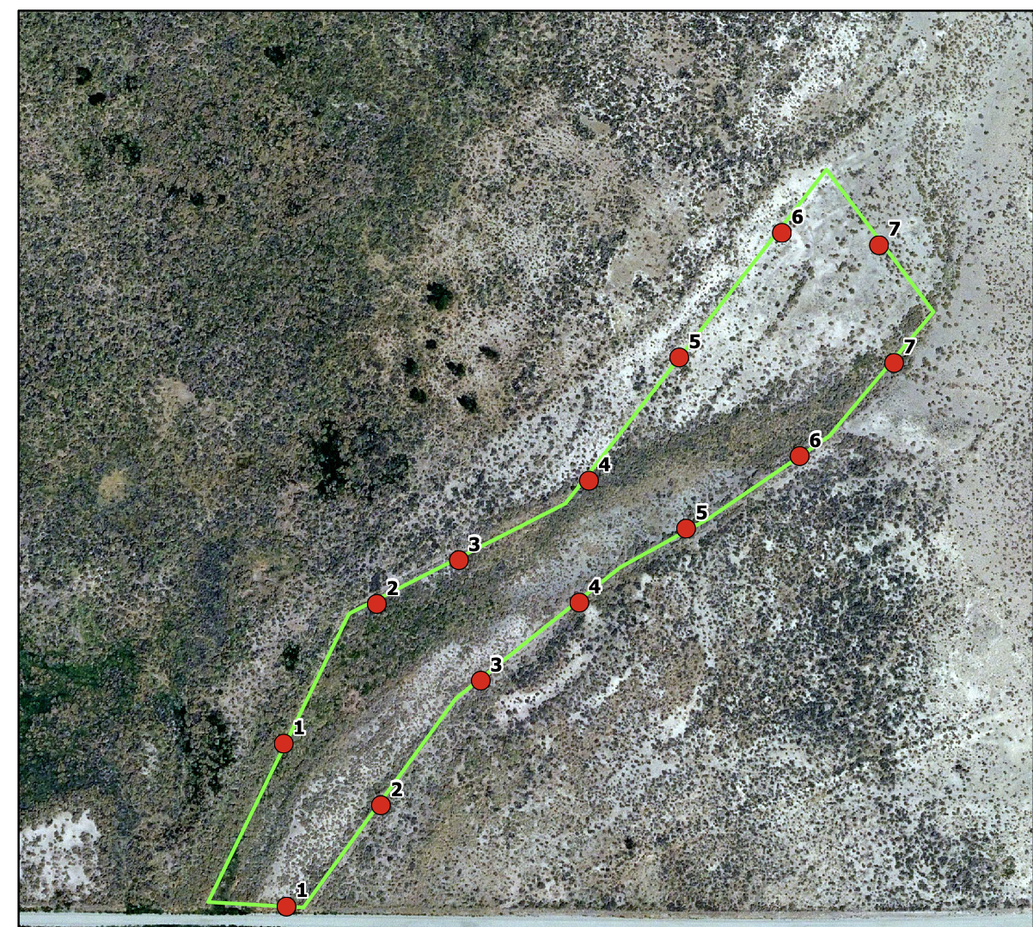

### 

### Hines Spring South

Need locations

Transect directions

1.1 -> 1.0 100m

2.1 -> 2.2 100m

2.2 -> 2.0 24m

3.1 -> 3.2 100m

3.2 -> 3.0 53m

4.1 -> 4.2 100m

4.2 -> 4.0 73m

5.1 -> 5.2 100m

5.2 -> 5.0 80m

### IND105

### IND131N

### IND131S

### IND123